PYTHON ASSIGNMENT 2 – PYTHON

LIST, DICTIONARY, SET & CONDITIONAL

STATEMENTS

TOOLS: Python / VS Code
PROJECT TITLE: Python Data Structures – List, Dictionary, Set & Conditional Statements
PROJECT OBJECTIVE: Working with Lists, Dictionaries and Sets – creation, modification and access – and implementing Conditional Statements (if, elif, else)
DATE OF SUBMISSION: 07/10/2026 – 1:30 PM

FILE SETUP:
CREATE A NEW PYTHON FILE "PYTHON LIST, DICTIONARY, SET & CONDITIONAL STATEMENTS.PY" IN VS CODE.
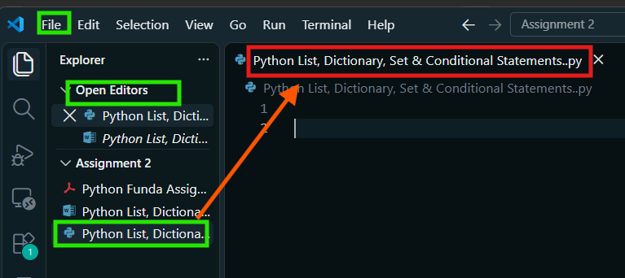
LIST (CREATION, MODIFICATION AND ACCESS):
1) LIST CREATION:
1.1) CREATE A LIST "AGE_LIST" WITH FIVE INTEGER ELEMENTS AND A LIST "NAME_LIST" WITH FIVE STRING ELEMENTS.
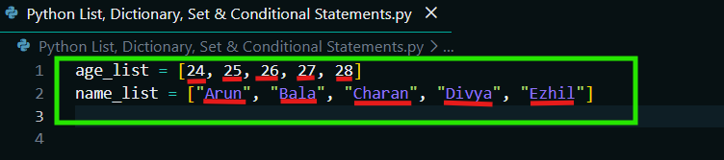
2) LIST OPERATIONS / MODIFICATIONS:
2.1) APPEND THE STRING "YAZHINI" TO "NAME_LIST" USING "APPEND()".
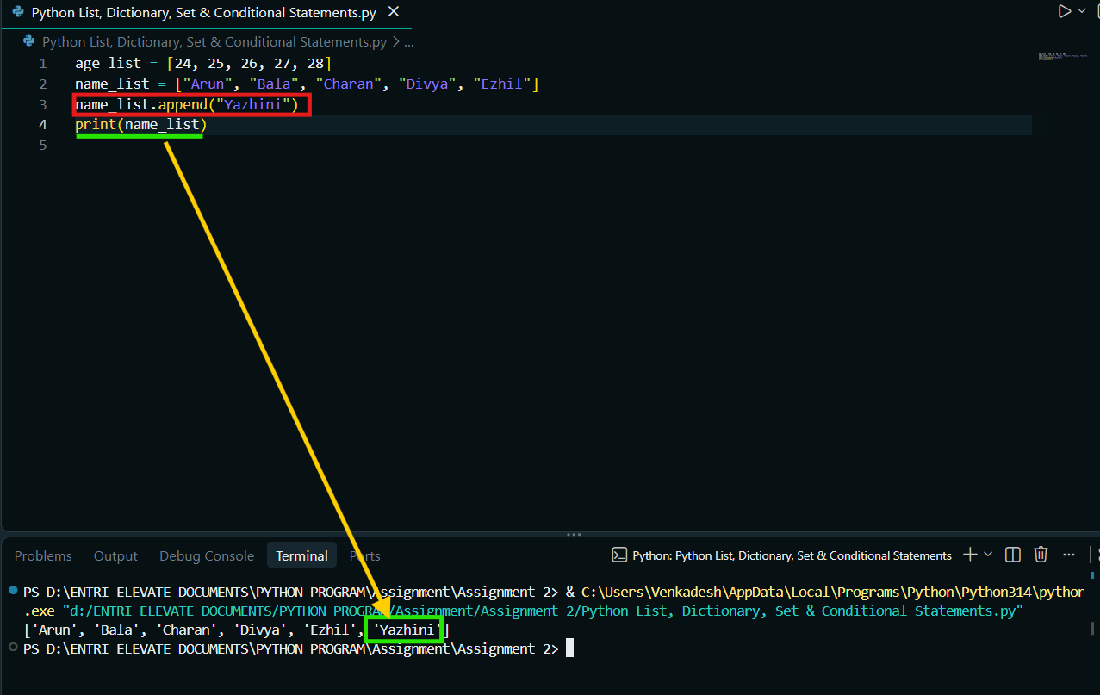
2.2) INSERT THE ELEMENT 30 AT INDEX 2 IN "AGE_LIST" USING "INSERT()".
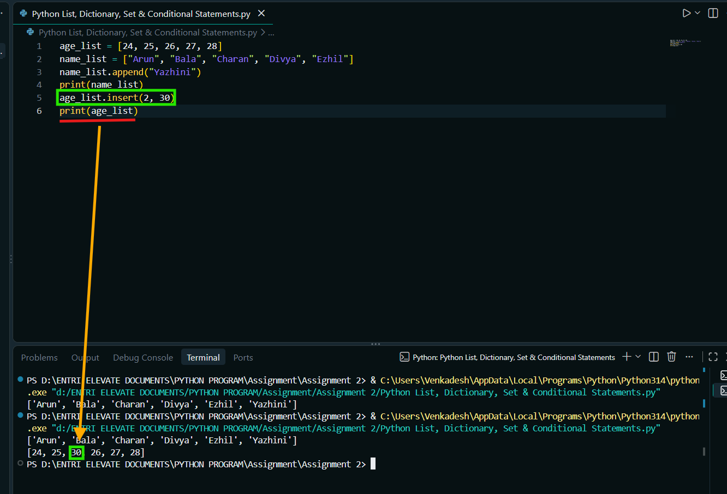
2.3) REMOVE THE STRING "YAZHINI" FROM "NAME_LIST" USING "REMOVE()" AND POP THE LAST ELEMENT FROM "AGE_LIST" USING "POP()".
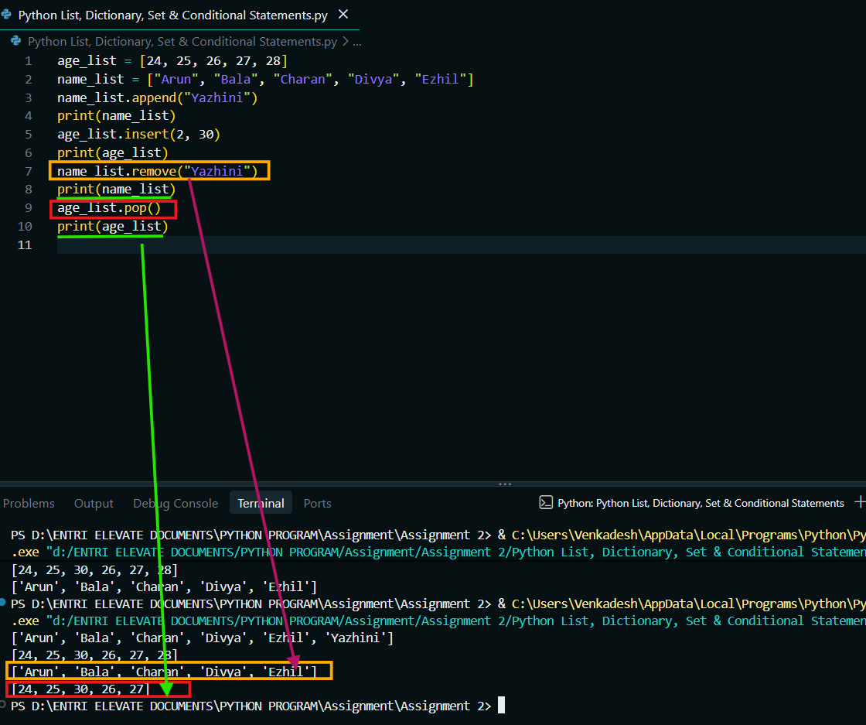
2.4) EXTEND "AGE_LIST" WITH [29, 30, 26] USING "EXTEND()" AND SORT IT IN DESCENDING ORDER USING "SORT(REVERSE=TRUE)".
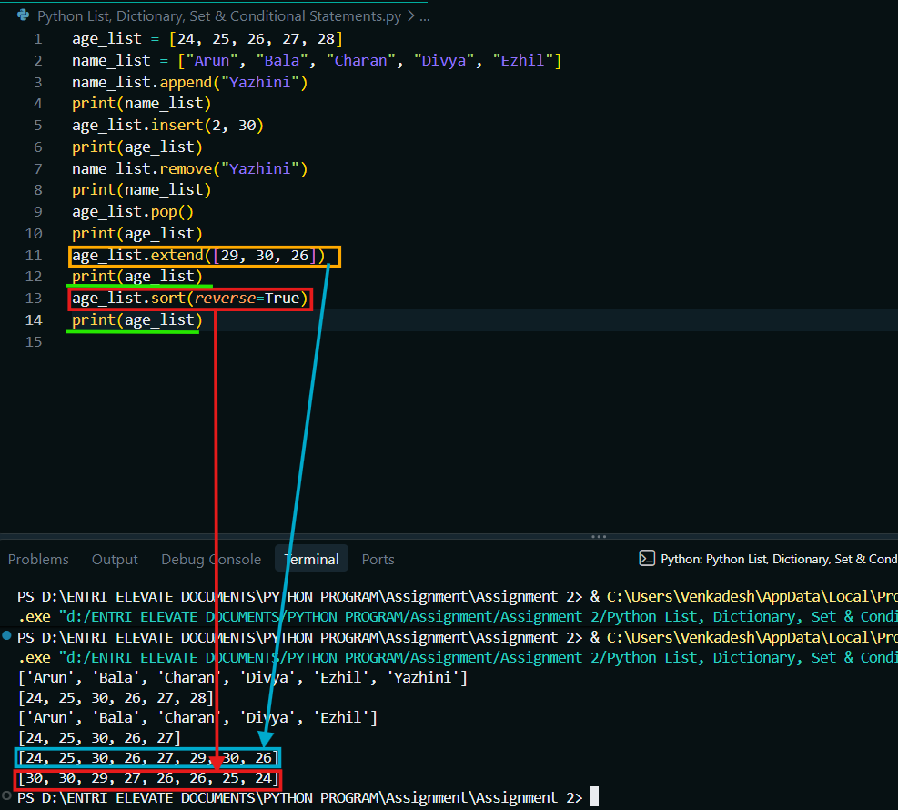
2.5) FIND THE MAXIMUM AGE, MINIMUM AGE AND SUM OF ALL AGES USING "MAX()", "MIN()" AND "SUM()".
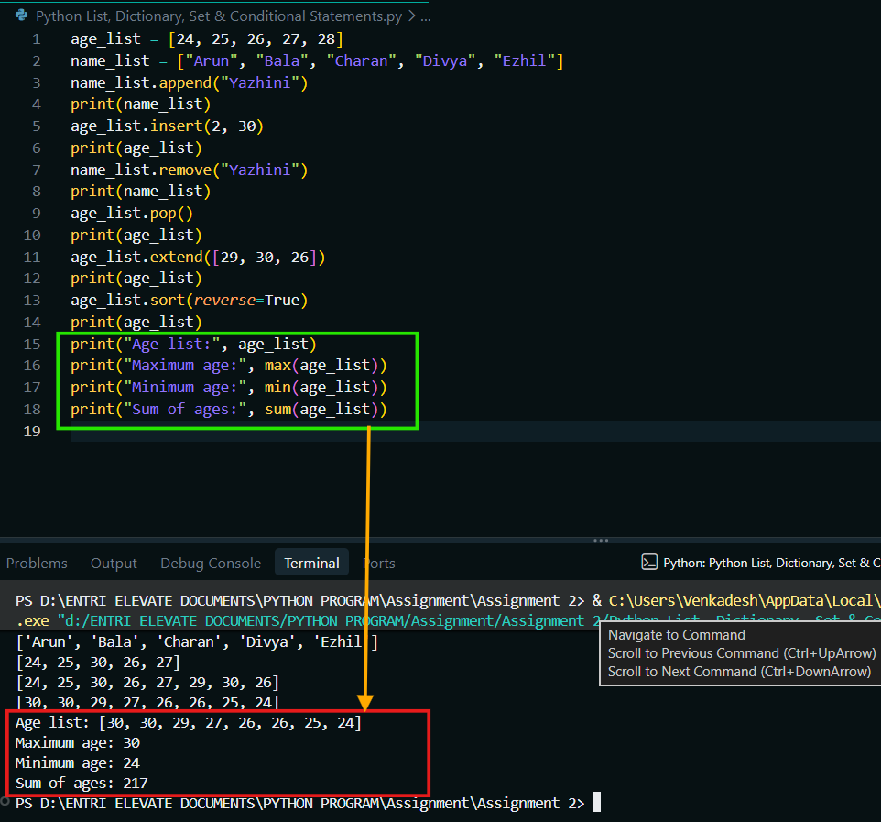

(SUMMARY) COMPLETE CODE AND OUTPUT OF ALL THE LIST MODIFICATIONS.
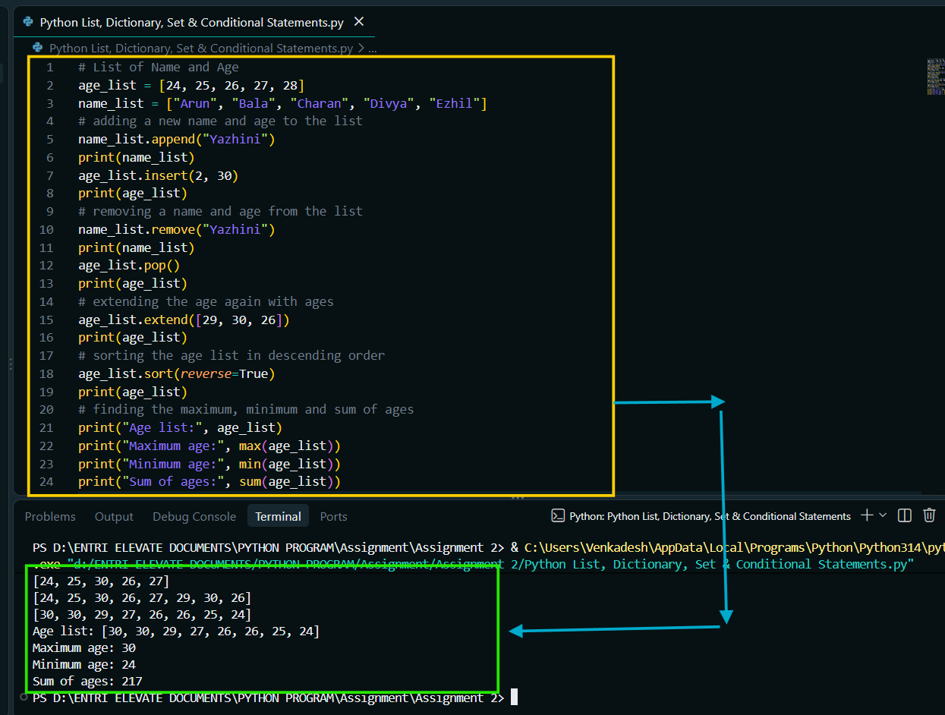
3) ACCESSING LIST ELEMENTS:
3.1) PRINT THE FIRST ELEMENT OF "NAME_LIST" USING INDEX "[0]".
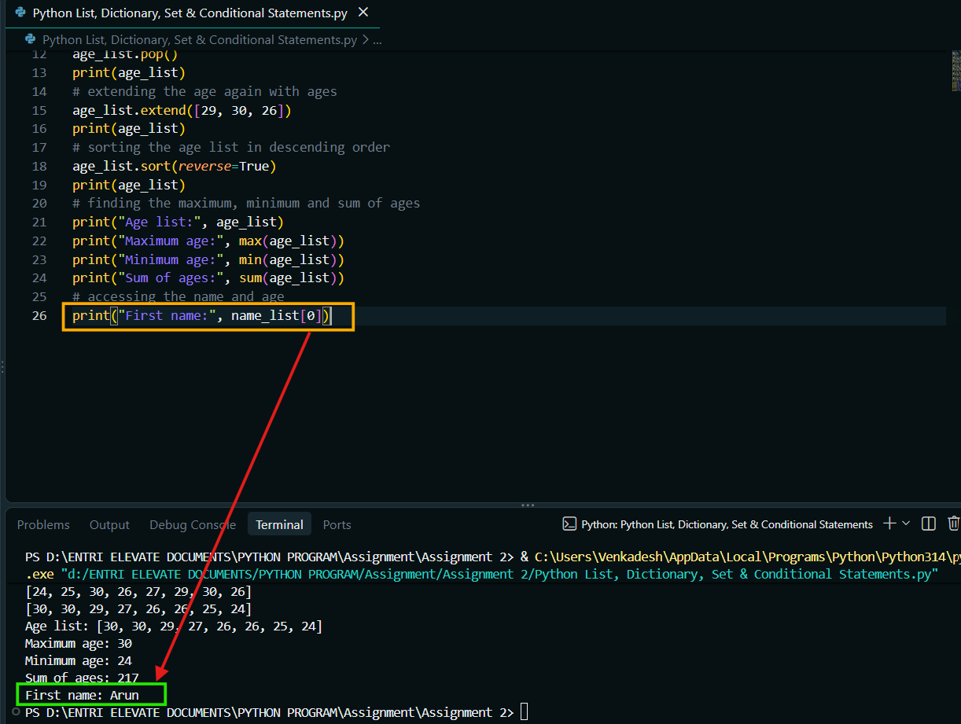
3.2) PRINT THE LAST ELEMENT OF "NAME_LIST" USING NEGATIVE INDEX "[-1]".
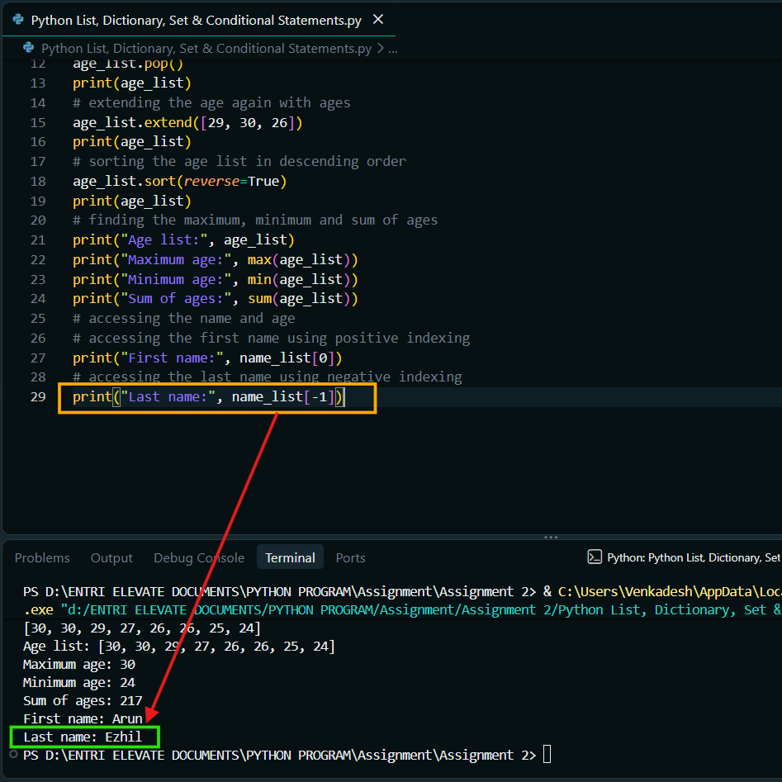

3.3) PRINT THE ELEMENTS FROM INDEX 2 TO INDEX 4 IN "NAME_LIST" USING THE SLICE "[2:5]".
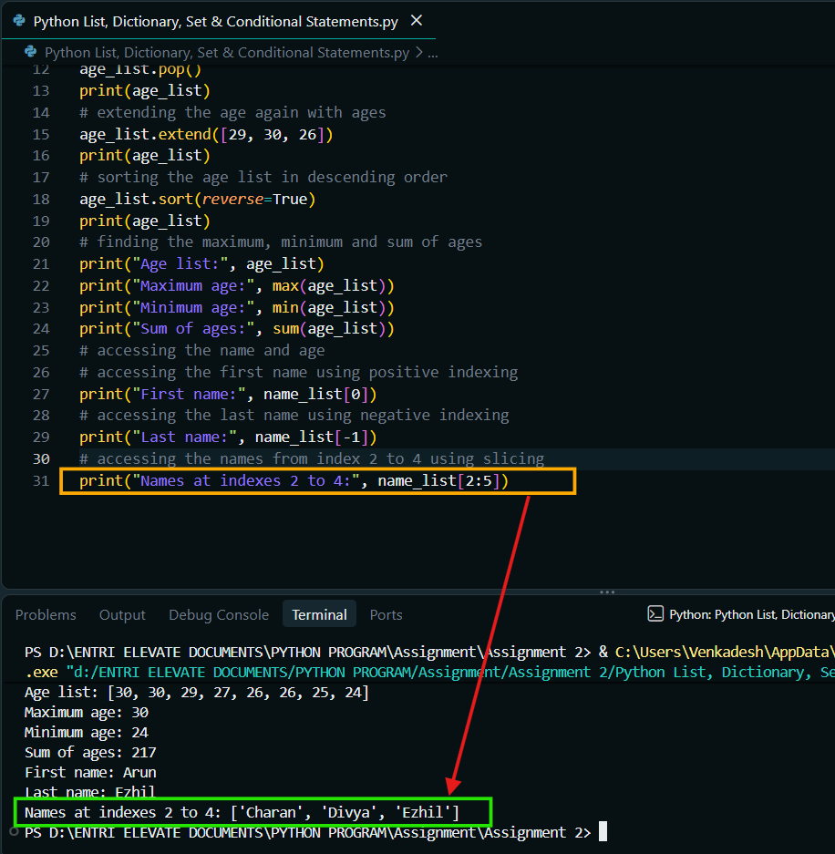
3.4) PRINT THE ELEMENTS OF "NAME_LIST" IN REVERSE ORDER USING THE SLICE "[::-1]".
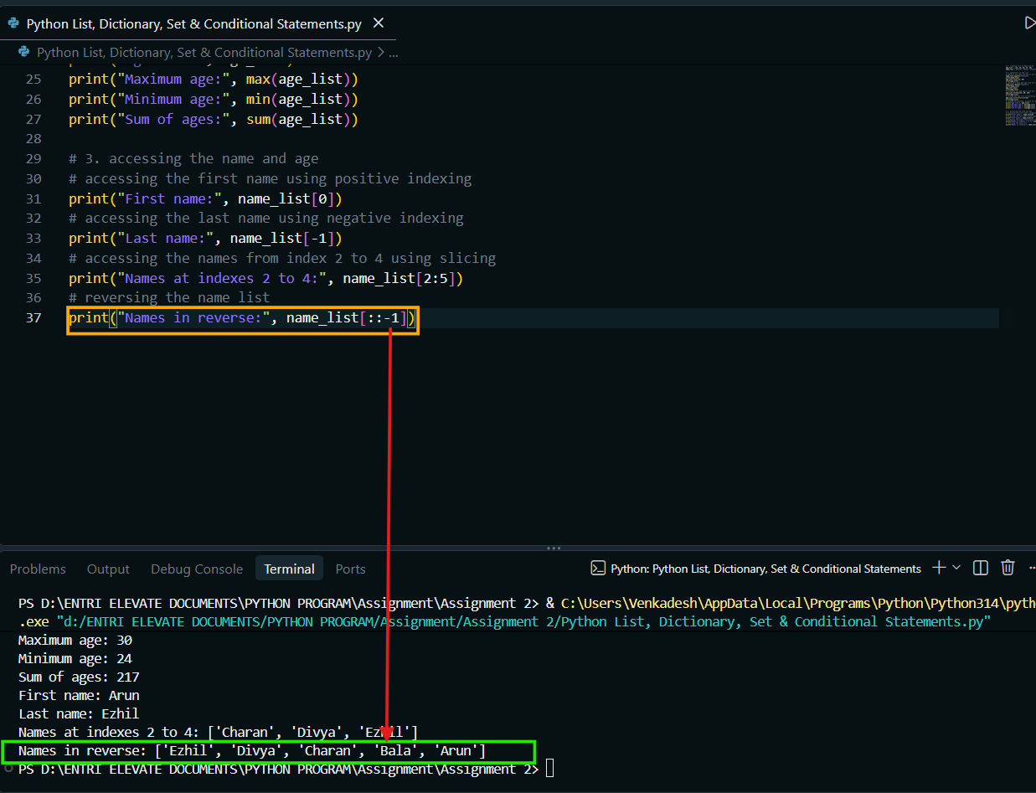
4) DICTIONARY (CREATION, MODIFICATION AND ACCESS):
4.1) CREATE A DICTIONARY "STUDENT_MARKS" MAPPING FIVE STUDENTS TO THEIR MARKS AND PRINT THE MARK OF "BALA".
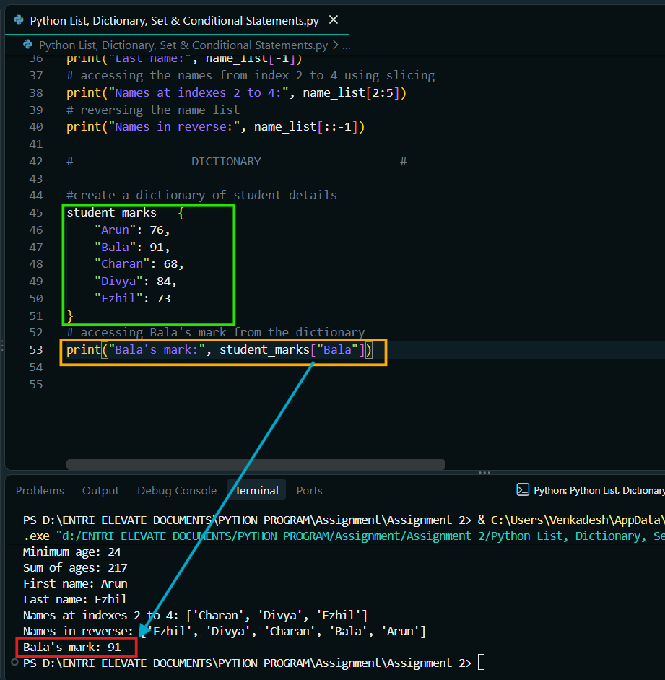
4.2) ADD A NEW STUDENT "JANANI" WITH MARK 80, UPDATE THE MARK OF "CHARAN" TO 82 AND PRINT ALL KEYS, VALUES AND ITEMS USING "KEYS()", "VALUES()" AND "ITEMS()".
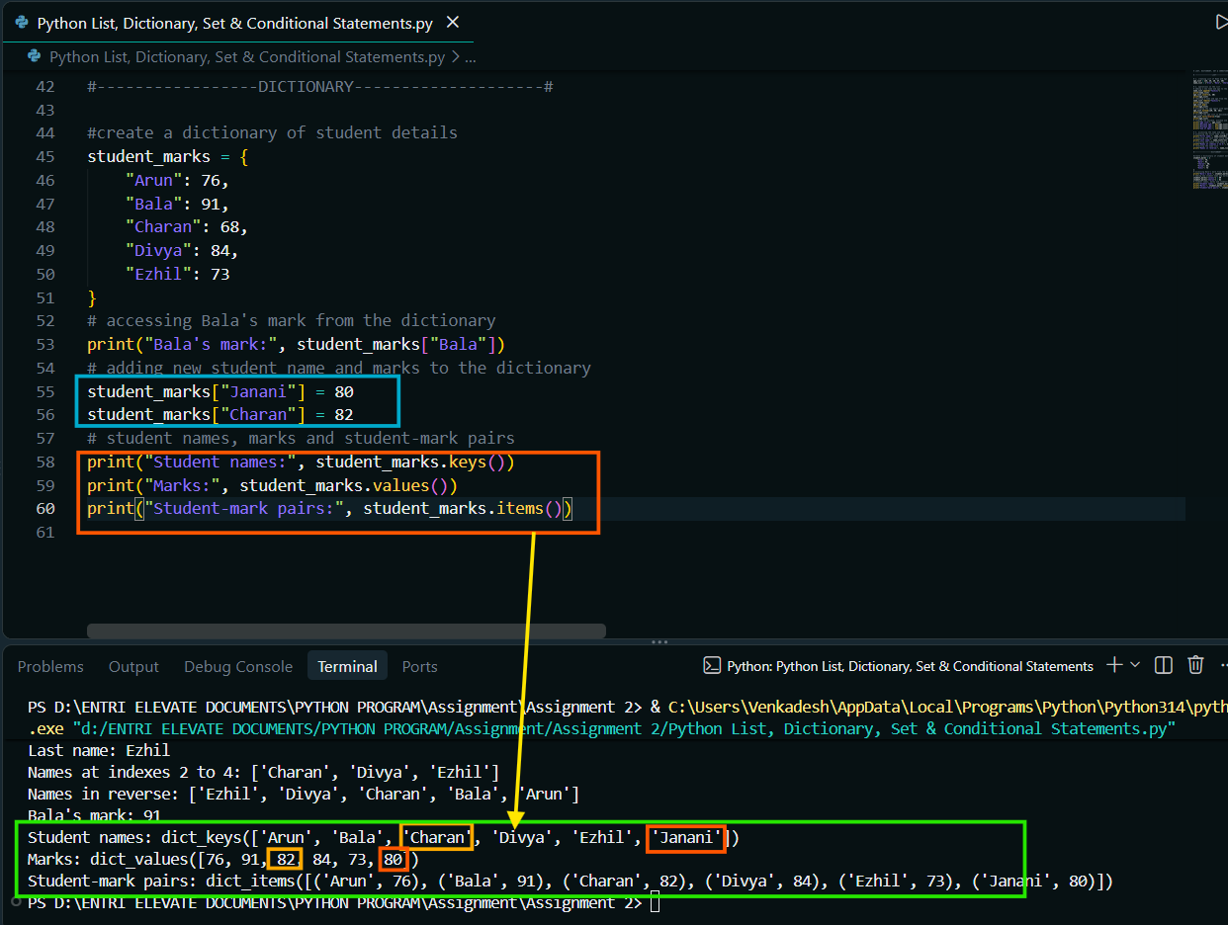
5) SETS (OPERATIONS):
5.1) CREATE A SET "MY_SET" FROM THE VALUES A, E, I, O, U, A, A, I AND PRINT IT.
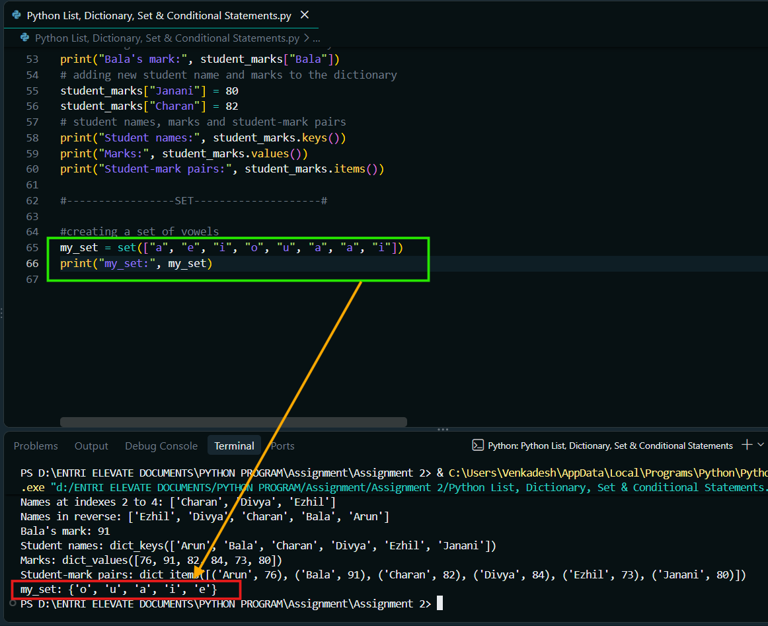
5.2) TRY TO CHANGE THE VALUE OF "MY_SET[4]" TO 'S' USING A "TRY-EXCEPT" BLOCK.
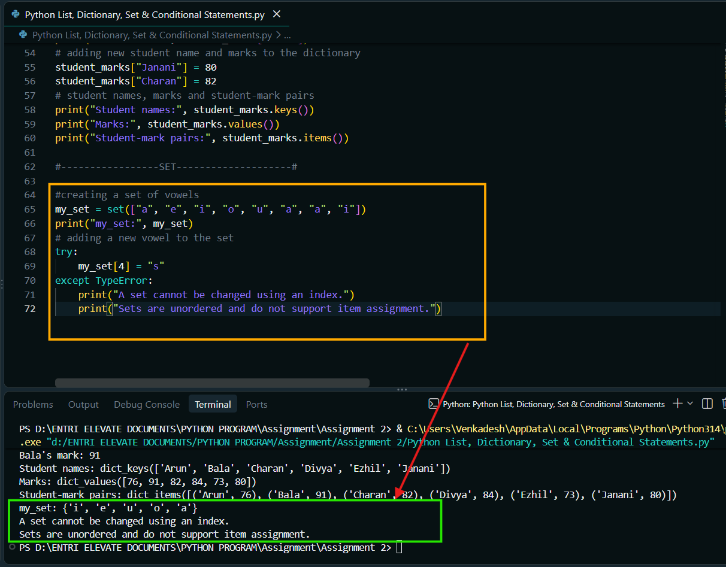
5.3) CREATE "SET1" AND "SET2" AND PRINT THEIR UNION USING THE "|" OPERATOR AND THEIR INTERSECTION USING THE "&" OPERATOR.
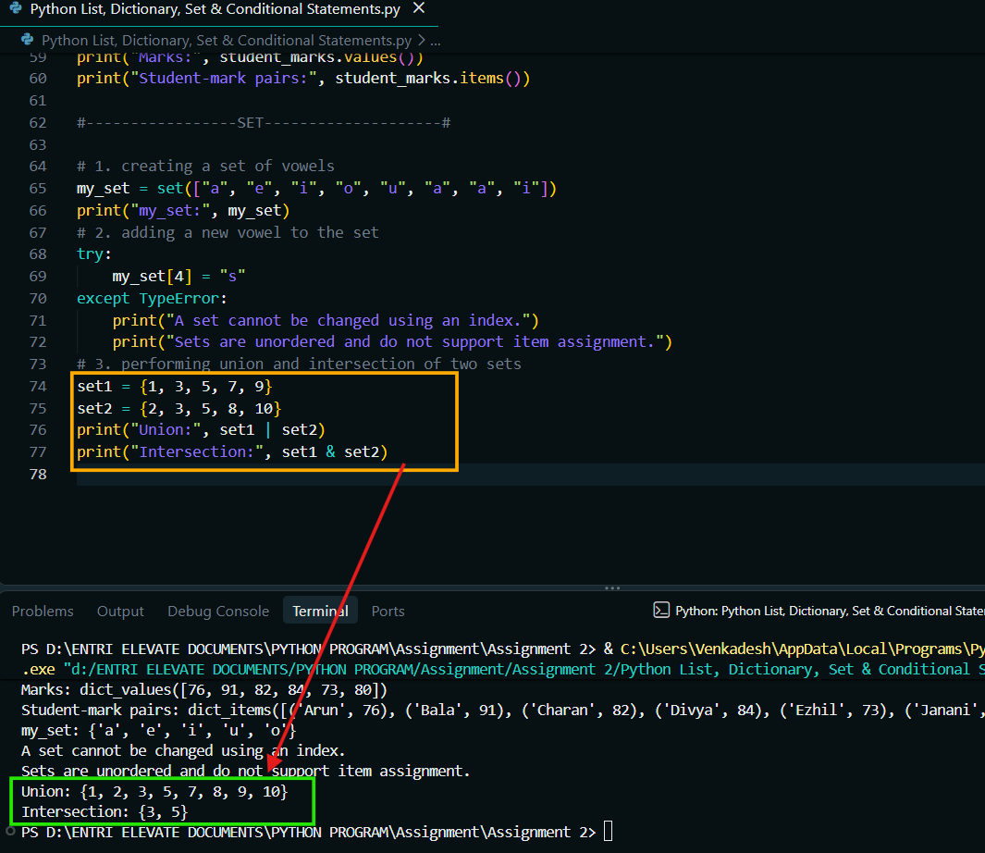
6) OPERATORS & CONDITIONAL STATEMENTS (IF, ELIF, ELSE):
PERFORMANCE CATEGORY PROGRAM:
6.1) READ A SCORE FROM 0 TO 10 AND PRINT THE PERFORMANCE CATEGORY USING "IF", "ELIF" AND "ELSE".
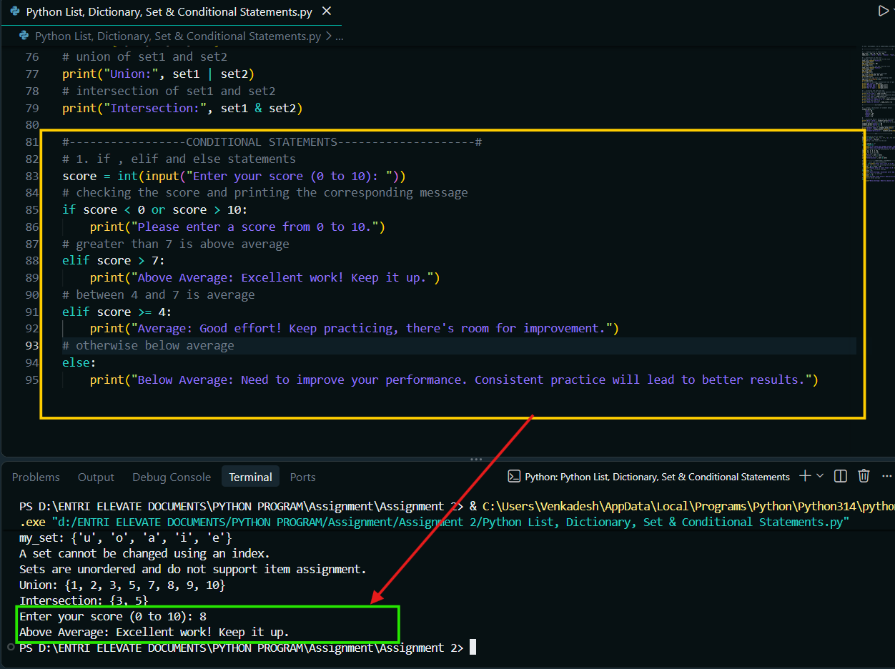

SOURCE CODE –
# LIST, DICTIONARY, SET & CONDITIONAL STATEMENTS

# -----------------LIST--------------------#

# 1. creating List of Name and Age
age_list = [24, 25, 26, 27, 28]
name_list = ["Arun", "Bala", "Charan", "Divya", "Ezhil"]
# 2. operations on the list
# adding a new name and age to the list
name_list.append("Yazhini")
print(name_list)
age_list.insert(2, 30)
print(age_list)
# removing a name and age from the list
name_list.remove("Yazhini")
print(name_list)
age_list.pop()
print(age_list)
# extending the age again with ages
age_list.extend([29, 30, 26])
print(age_list)
# sorting the age list in descending order
age_list.sort(reverse=True)
print(age_list)
# finding the maximum, minimum and sum of ages
print("Age list:", age_list)
print("Maximum age:", max(age_list))
print("Minimum age:", min(age_list))
print("Sum of ages:", sum(age_list))
# 3. accessing the name and age
# accessing the first name using positive indexing
print("First name:", name_list[0])
# accessing the last name using negative indexing
print("Last name:", name_list[-1])
# accessing the names from index 2 to 4 using slicing
print("Names at indexes 2 to 4:", name_list[2:5])
# reversing the name list
print("Names in reverse:", name_list[::-1])

#-----------------DICTIONARY--------------------#

# 1. create a dictionary of student details
student_marks = {
"Arun": 76,
"Bala": 91,
"Charan": 68,
"Divya": 84,
"Ezhil": 73
}
# 2. accessing Bala's mark from the dictionary
print("Bala's mark:", student_marks["Bala"])
# 3. adding new student name and marks to the dictionary
student_marks["Janani"] = 80
student_marks["Charan"] = 82
# 4. student names, marks and student-mark pairs
print("Student names:", student_marks.keys())
print("Marks:", student_marks.values())
print("Student-mark pairs:", student_marks.items())

#-----------------SET--------------------#

# 1. creating a set of vowels
my_set = set(["a", "e", "i", "o", "u", "a", "a", "i"])
print("my_set:", my_set)
# 2. adding a new vowel to the set
try:
my_set[4] = "s"
except TypeError:
print("A set cannot be changed using an index.")
print("Sets are unordered and do not support item assignment.")
# 3. performing union and intersection of two sets
set1 = {1, 3, 5, 7, 9}
set2 = {2, 3, 5, 8, 10}
# union of set1 and set2
print("Union:", set1 | set2)
# intersection of set1 and set2
print("Intersection:", set1 & set2)

#-----------------CONDITIONAL STATEMENTS--------------------#
# 1. if , elif and else statements
score = int(input("Enter your score (0 to 10): "))
# checking the score and printing the corresponding message
if score < 0 or score > 10:
print("Please enter a score from 0 to 10.")
# greater than 7 is above average
elif score > 7:
print("Above Average: Excellent work! Keep it up.")
# between 4 and 7 is average
elif score >= 4:
print("Average: Good effort! Keep practicing, there's room for improvement.")
# otherwise below average
else:
print("Below Average: Need to improve your performance. Consistent practice will lead to better results.")

OUTPUT –
PS D:\ENTRI ELEVATE DOCUMENTS\PYTHON PROGRAM\Assignment\Assignment 2> & C:\Users\Venkadesh\AppData\Local\Programs\Python\Python314\python.exe "d:/ENTRI ELEVATE DOCUMENTS/PYTHON PROGRAM/Assignment/Assignment 2/Python List, Dictionary, Set & Conditional Statements.py"
['Arun', 'Bala', 'Charan', 'Divya', 'Ezhil', 'Yazhini']
[24, 25, 30, 26, 27, 28]
['Arun', 'Bala', 'Charan', 'Divya', 'Ezhil']
[24, 25, 30, 26, 27]
[24, 25, 30, 26, 27, 29, 30, 26]
[30, 30, 29, 27, 26, 26, 25, 24]
Age list: [30, 30, 29, 27, 26, 26, 25, 24]
Maximum age: 30
Minimum age: 24
Sum of ages: 217
First name: Arun
Last name: Ezhil
Names at indexes 2 to 4: ['Charan', 'Divya', 'Ezhil']
Names in reverse: ['Ezhil', 'Divya', 'Charan', 'Bala', 'Arun']
Bala's mark: 91
Student names: dict_keys(['Arun', 'Bala', 'Charan', 'Divya', 'Ezhil', 'Janani'])
Marks: dict_values([76, 91, 82, 84, 73, 80])
Student-mark pairs: dict_items([('Arun', 76), ('Bala', 91), ('Charan', 82), ('Divya', 84), ('Ezhil', 73), ('Janani', 80)])
my_set: {'e', 'a', 'o', 'i', 'u'}
A set cannot be changed using an index.
Sets are unordered and do not support item assignment.
Union: {1, 2, 3, 5, 7, 8, 9, 10}
Intersection: {3, 5}
Enter your score (0 to 10): 9
Above Average: Excellent work! Keep it up.

